# Span:

|  |  |  |  |
| --- | --- | --- | --- |
| **Single AZ** | **Span Multi-AZ** | **Single Region** | **Span Multi-Region** |
| RedShift | Reserved EC2 Instances | Security Group | IAM – Roles, Groups, Users, Policy |
|  | ELB (In Single Region) | ELB |  |
| Placement Groups | SWF – Manages workflow history across 03 AZs  SNS – Published msgs are redundantly stored across multi-AZs | AMIs  (However can be copied to other regions) |  |
|  |  | VPC |  |
|  |  | SQS |  |
|  |  |  | S3 - Global |

# Replication:

|  |  |  |
| --- | --- | --- |
| **Synchronous** | **Asynchronous** | **Place** |
|  | EBS Snapshots | EBS Replication in Same AZ. |
|  |  |  |
|  |  |  |
|  |  |  |
|  |  |  |
|  |  |  |

# Compute

## EC2

* Max Number of Tags – 10 Per EC2 Instance
* How many regions are there on the AWS platform currently - 11
* Total Regions Supported for EC2 - 9
* EC2 Instance Limits (Per Region)
* On-Demand : 20
* Reserved: 20
* SPOT – No Limit

## Auto Scaling

* Default Cooling Period – 5 mins

# Storage

## S3

* Per AWS A/c S3 Buckets – 100
* File Size: 1 Byte – 5 TB
* Object/File Size in Single PUT – 5 GB

## Glacier

* 1000 Vaults – Per Region
* 1 Byte – 40 TB
* Object/File Size in Single PUT – 4 GB

## Storage Gateway

* Gateway Stored Volume – 16 TB, 32 Volumes: 512 TB
* Gateway Cached Volume – 32 TB, 32 Volumes: 1 PB
* Virtual Tape – 1 PB (1500 Virtual Tapes)

## Import/Export

* Max Device Capacity – 16 TB
* Snowball - Max Device Capacity – 50 TB

## CloudFront:

* 1000 – Request Per Second
* Max File Size Delivery – 20 GB
* TTL – 24 Hrs (86400 secs)

# Database

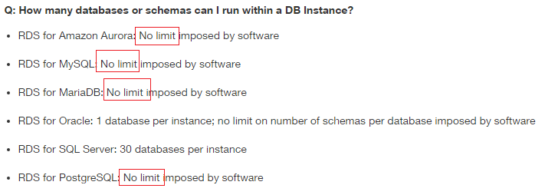

## RDS:

* Limit – 40 RDS Instances
* Max DB on Single SQL-Server Instance – 30
* Max DB on Single Oracle Instance – 01
* Backup Retention Period – 1 - 35 Days
* Read-Replicas – 05
* MySQL DB Size – 6 TB
* Maximum size for a Microsoft SQL Server DB Instance with SQL Server Express edition – 10 GB (SA Mega Quiz #20)

## Dynamo DB

* Storage – No Limit
* Local Secondary Index – 05
* Streams – Stored for 24 Hours only.

## RedShift

* Block Size – 1024 KB
* Maintain 3 copies

# Networking

## ELB:

* Allowed Load balancer : 20

## Per Region

* 05 - VPCs
* 05 - EIP
* 05 – Virtual Private Gateway
* 50 - VPN Connections
* 50 – Customer Gateway

## Per VPC

* 01 - Internet Gateway
* 01 – IP Address Range
* 200 – Subnets
* 20 - EC2 Instances (Default)

Per Subnet

* 01 – AZ
* 01 - ACL

## Route53

* Number of domains you can manage using Route 53 is 50 (however it is a soft limit and can be raised by contacting AWS support)

# Management

## Cloud Watch

* Logs – Unlimited
* Alarms – 2 Weeks
* Metrics – 2 Weeks

## Cloud Formation

* Templates – No Limits
* Stack – 200 Per A/c

## Cloud Trail

* 5 Trails – Per Region

## OpsWorks

* 40 Stacks
* 40 Layers
* 40 Instances
* 40 - Apps

# Security

* Roles: 250 Per AWS Account
* KMS
* Master Keys – 1000 Per AWS A/c
* Data Key – No Limit

# Analytics

EMR:

* EC2 Instances Across All clusters - 20

# Application

## SQS:

* Visibility Timeout – 30 Secs (Default) (Otherwise 12 hours)
* Retention Period – 4 days (Default). Can be set form 1 min to 2 Weeks (14 Days)
* Max Long Polling Timeout – 20 Secs
* Number of Queues – Unlimited
* Number of messages per queue – Unlimited

## SES:

* SES Email Size – 10 MB (including Attachments)
* SES Recipients – 50 for every message
* Sending Limits:

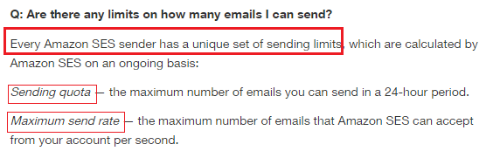

## SNS:

* Topic – 1 Lakh (Per A/c)
* Subscription – 10 Million Per Topic (Per A/c)
* TTL – 04 Weeks

## SWF:

* Retention Period – 1 Year

## Elastic Encoder

* Jobs – 10k Per Pipeline